Isuzu Motors Co., (Thailand) Ltd.

RT50 Frame No.2 Line
Line Monitoring System (LMS2)
SETUP MANUAL

OMRON

OMRON
TABLE OF CONTENTS
Installation Manual 1
Restore the Database 1
Setup the IMCT_RT50FrameNo2Line_LMS_Server 8
Setup the .NET Framework 9
Setup Application 10
Changing the configuration 13
Setup the IMCT_RT50FrameNo2Line_LMS_Client 16
Setup the .NET Framework 16
Setup Application 17
Changing the configuration 21
IP Address Setting 24

Installation Manual
- Restore the Database (on the Server computer)
- Setup the IMCT_RT50FrameNo2Line_LMS_Server (on the Server computer)
- Setup the IMCT_RT50FrameNo2Line_LMS_Client (on the Client Computers)

Restore the Database
Open the Ms.SQL Server Management Studio for restore the database, first time the software will ask the username and password as Figure 1-1
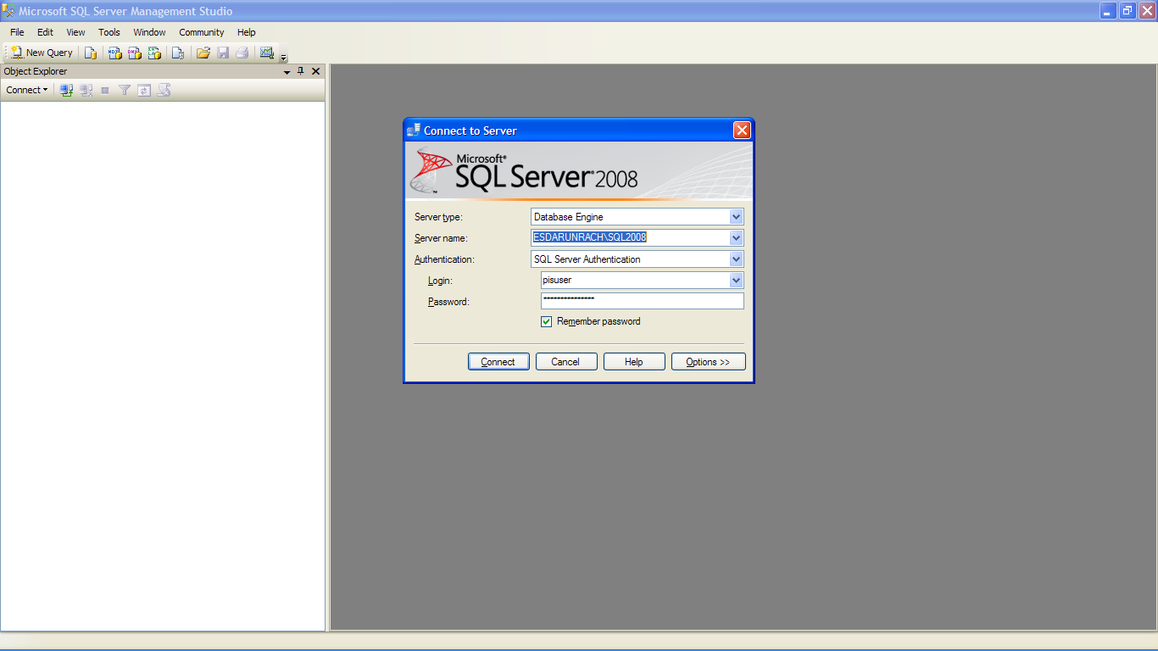
Figure 1-1 Ms.SQL Server first time start up with username and password dialog

After enter the correct username and password, the Ms.SQL Server Management Studio main screen will be shown as Figure 1-2
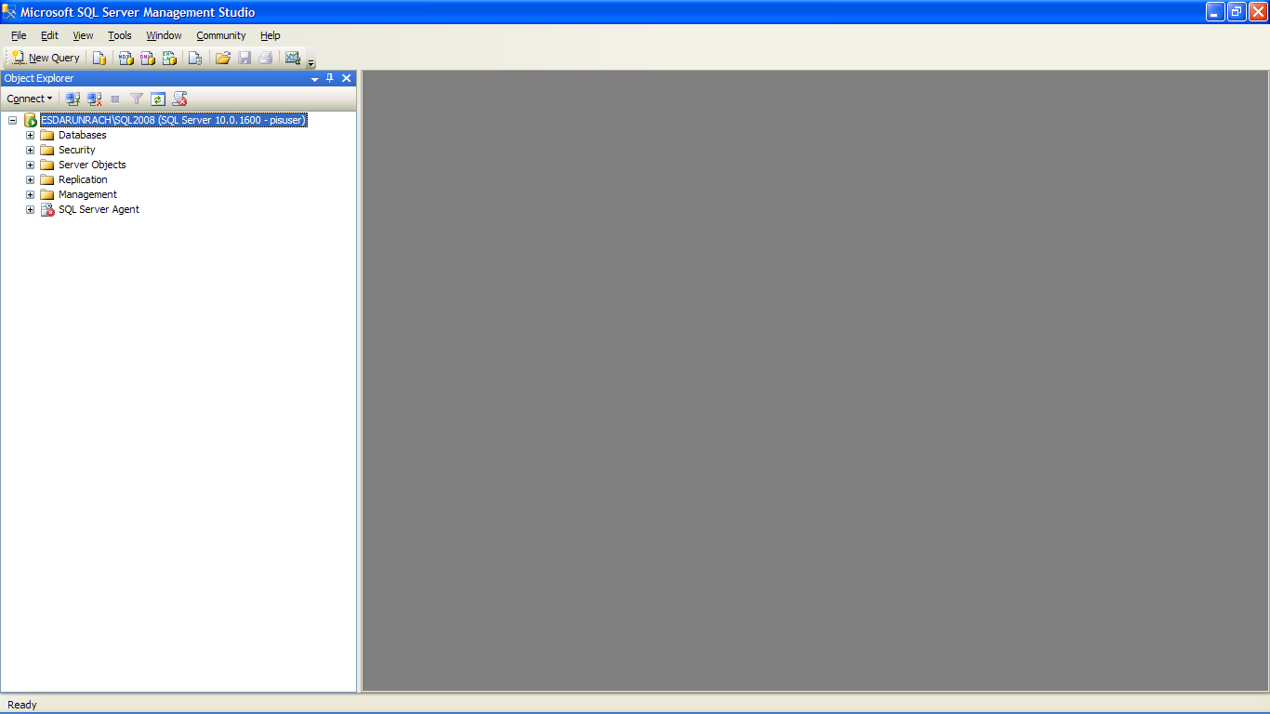
Figure 1-2 Ms.SQL Server Main Screen
To restore the IMCT_FrameLineNo2_EMS_DB database by Right-Click at the database menu and select the “Restore Database…” menu as Figure 1-3
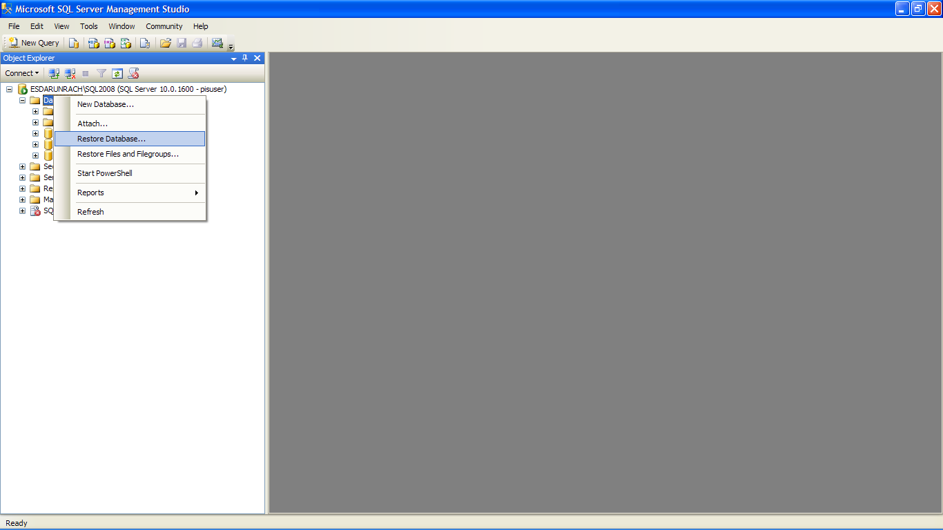
Figure 1-3 Select Menu Restore Database
After select the above menu the Restore Database dialog will be shown as Figure 1-4
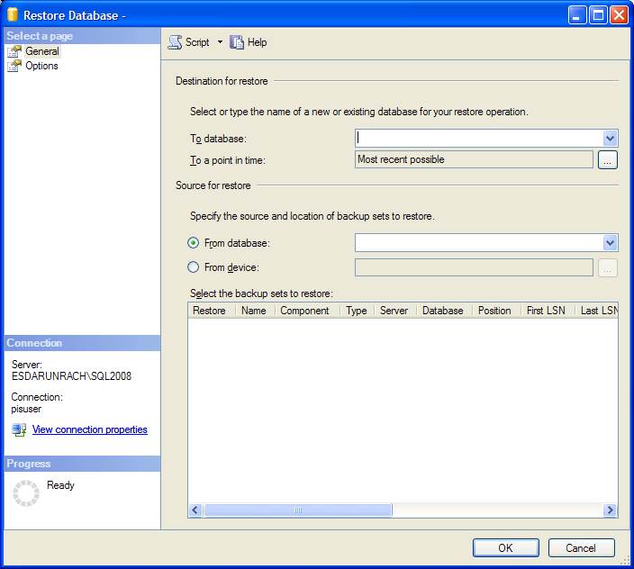
A
B
Figure 1-4 Restore Database Dialog
In the “To Database” (A) text box, input “IMCT_FrameLineNo2_EMS_DB”,
Select From Device (B) and then click the […] at the end of line From Device, the Specify Backup dialog will be shown as Figure 1-5
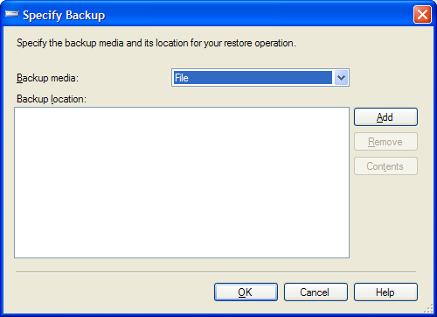
Figure 1-5 Specify Backup Dialog
Click the “Add” button, then the Locate Backup File dialog will be shown as Figure 1-6

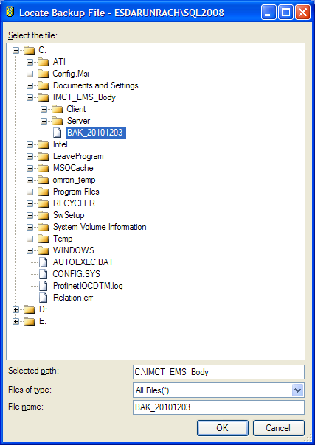
Figure 1-6 Locate Backup File Dialog
Select the backup file at the specified folder and click OK button. Program will be back to the Figure 1-7
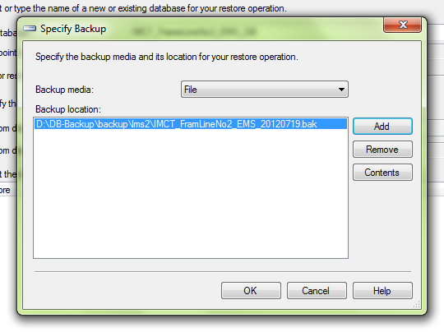
Figure 1-7 Specify Backup Dialog after Select File
From the Figure 1-7 click OK button, program will also come back to the screen as Figure 1-8
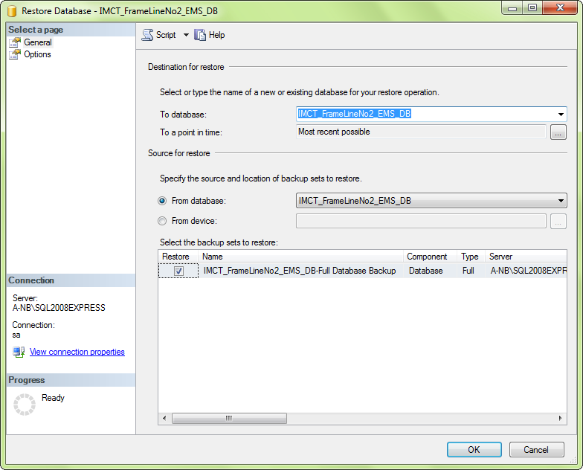
Figure 1-8 Restore Database Dialog after Select File
Check the check box in front of file name and click the OK button. Program will process the restore as Figure 1-9, then after completion of restore database the complete dialog will be shown as Figure 1-10

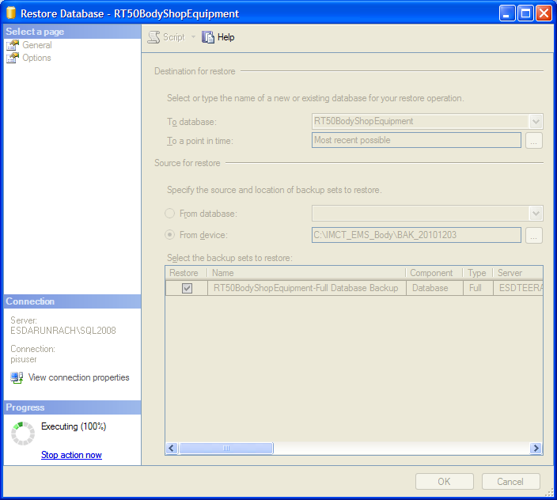
Figure 1-9 Restore Database Dialog while perform restore

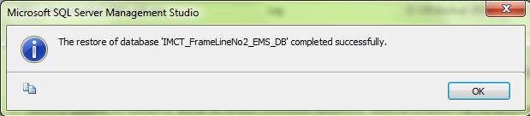
Figure 1-10 Completed Dialog
Click the OK button for back to MS.SQL main screen
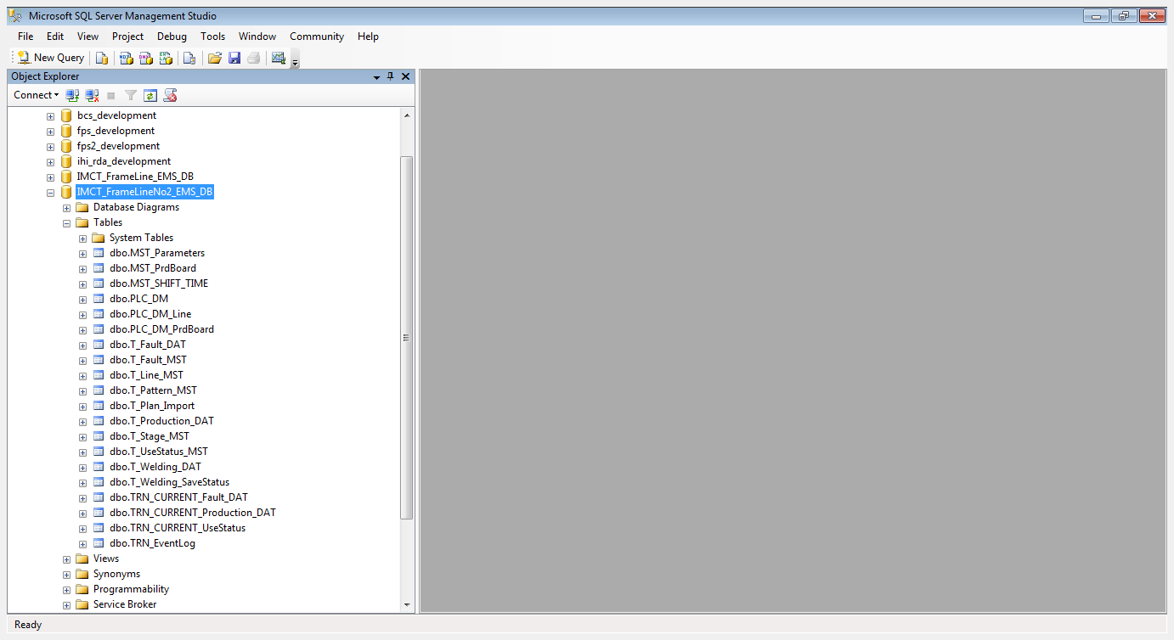
Figure 1-11 Main screen after restore

Setup the IMCT_RT50FrameNo2Line_LMS_Server
Open the folder which contains the setup file of the IMCT_RT50FrameNo2Line_LMS_Server in CD or storage drive, as the Figure 2-1, click the file Setup.EXE

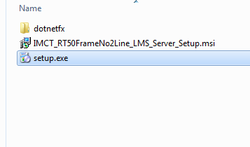
Figure 2-1 The IMCT_RT50FrameNo2Line_LMS_Server setup folder
After click the Setup.EXE, From Figure 2-1, program will start the setup procedure. In case of the first time installation or the computer does not have the .NET Framework software, program will automatically setup the .NET Framework before, as shown in Figure 2-2.
In case of the computer machine already has the .NET Framework software the program will skip this operation to Figure 2-4.

Setup the .NET Framework
The .NET Framework program
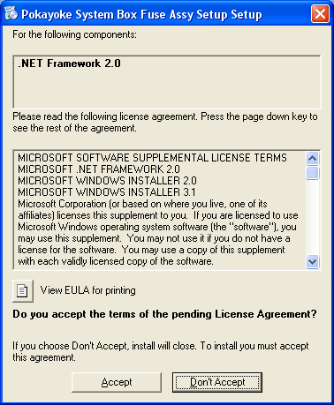
Figure 2-2 Setup the .NET Framework
From Figure2, Click the Accept button for start the setup of .NET Framework the program will show the progression bar as the Figure3 until the installation of .NET Framework is completed.

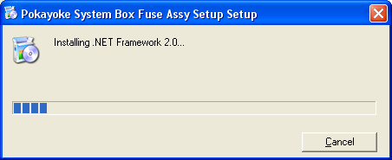
Figure 2-3 Progression bar while the .NET Framework is being setup

Setup Application
After already setup the .NET Framework, the program will start to setup the Application as Figure 2-4
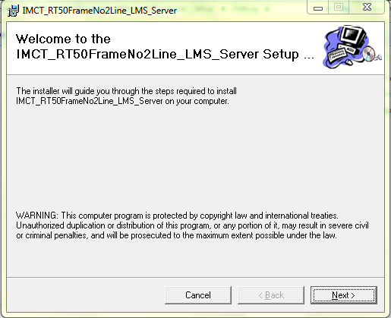
Figure 2-4 first screen of application setup
Click the Next button program will shown as the Figure 5 for select the installed folder (the default is “C:\Program Files\Omron Electronics\IMCT_RT50FrameNo2Line_LMS_Server”)

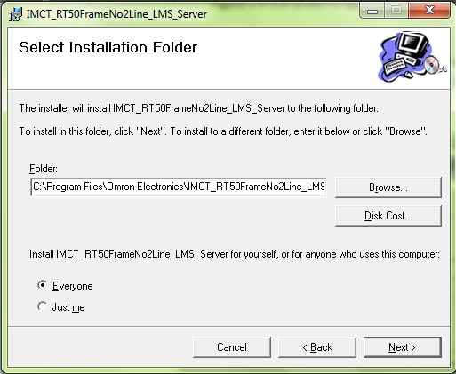
Figure 2-5 Dialog for ask the installed folder
After define the installed folder click the Next button, program will show the dialog as Figure 2-6
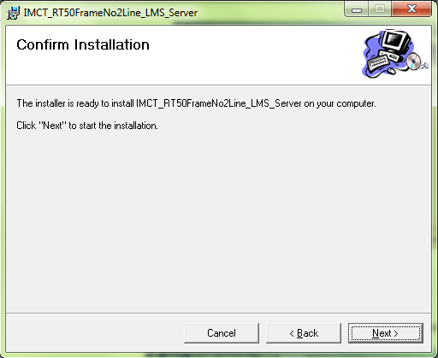
Figure 2-6 Confirm Installation dialog
Click the Next button the progress bar of installation will be shown as Figure 2-7
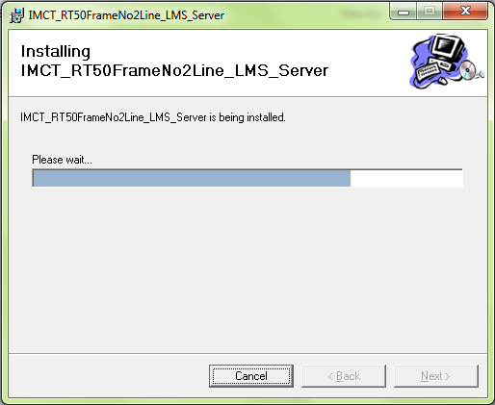
Figure 2-7 the progress bar of installation
After the installation is completely installed the Installation Complete dialog will be shown as Figure 2-8
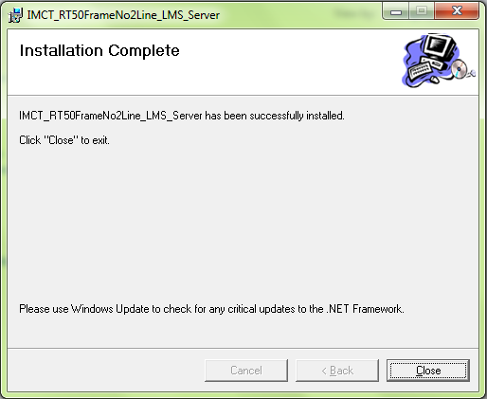
Figure 2-8 Installation complete dialog
Click the Close button for finish install.

After completed installation of the IMCT_RT50FrameNo2Line_LMS_Server, user can Start up the application by click the Start→Program → IMCT_RT50FrameNo2Line_LMS_Server → IMCT_RT50FrameNo2Line_LMS_Server, as Figure 2-9, or click the IMCT_RT50FrameNo2Line_LMS_Server button in the desktop, as Figure 2-10
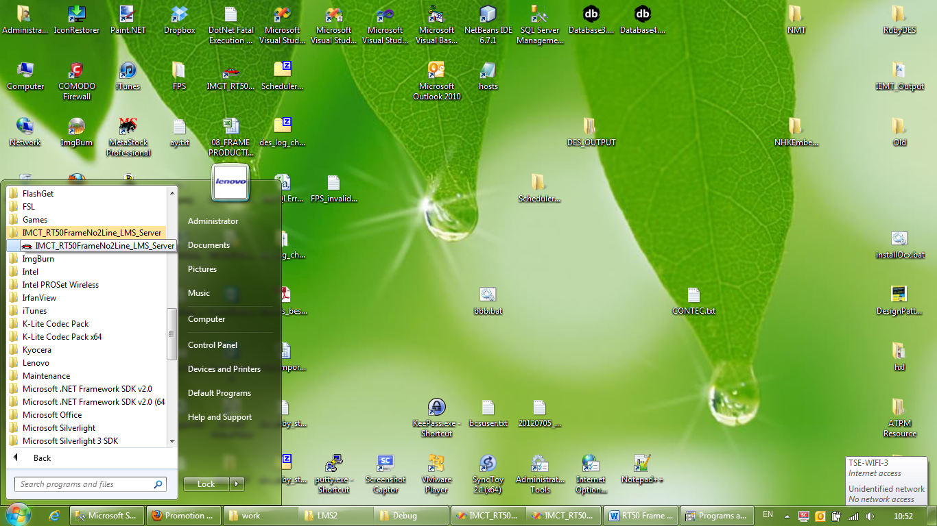
Figure 2-9 Menu in MS-Windows
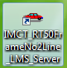
Figure 2-10 the short cut icon in MS-Windows desktop

Changing the configuration
For the first time, after installation completed but before start the application. User must change some setting configuration, for example the server name (or IP address) , Database instance name, default connection user and password.
Open the application folder (default is “C:\Program Files\Omron Electronics\IMCT_RT50FrameNo2Line_LMS_Server”) as Figure 2-11
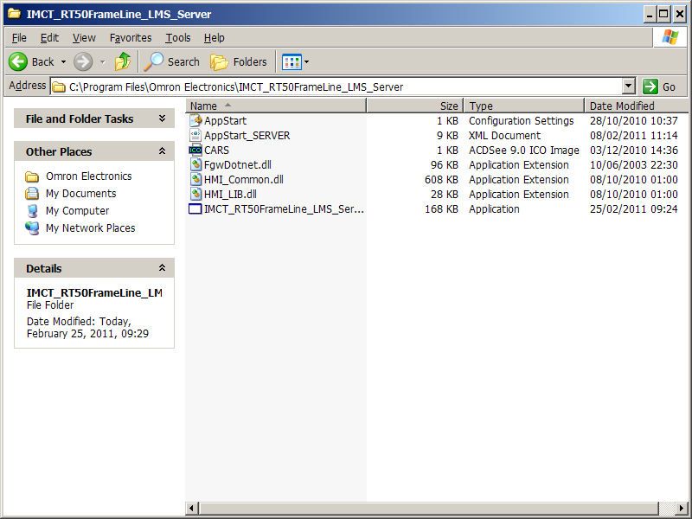
Figure 2-11 Application Folder
Open the file APPSTART_SERVER.XML and change database connection setting
<AppStart_Config>  <CFG_Name>DB_INITIAL_CATALOG</CFG_Name>  <CFG_Value> IMCT_FrameLineNo2_EMS_DB </CFG_Value>  </AppStart_Config> | Database Name must be “IMCT_FrameLine_EMS_DB”
<AppStart_Config>  <CFG_Name>DB_DATA_SOURCE</CFG_Name>  <CFG_Value>localhost</CFG_Value>  </AppStart_Config> | Server name and database instance (default is localhost). For example if the Servername is “PISServer” and Database name is “SQL2008”, change the localhost to be PISSERVER\SQL2008 or IP Address
<AppStart_Config>  <CFG_Name>DB_CONNECT_USERNAME</CFG_Name>  <CFG_Value>sa</CFG_Value>  </AppStart_Config> | Change to be the actual connection user name
<AppStart_Config>  <CFG_Name>DB_CONNECT_PASSWORD</CFG_Name>  <CFG_Value>omron</CFG_Value>  </AppStart_Config> | Change to be the actual connection password
<AppStart_Config>  <CFG_Name>DB_CONNECT_DEFAULTUSER</CFG_Name>  <CFG_Value>1</CFG_Value>  </AppStart_Config> | Change to be “0”

Setup the IMCT_RT50FrameNo2Line_LMS_Client
Open the folder which contains the setup file of the IMCT_RT50FrameNo2Line_LMS_Client in CD or storage drive, as the Figure 3-1, click the file Setup.EXE
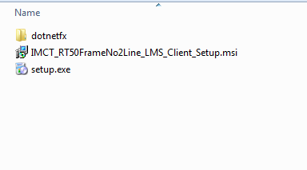
Figure 3-1 The IMCT_RT50FrameNo2Line_LMS_Clientsetup folder
After click the Setup.EXE, From Figure 3-1, program will start the setup procedure. In case of the first time installation or the computer does not have the .NET Framework software, program will automatically setup the .NET Framework before, as shown in Figure 3-2.
In case of the computer machine already has the .NET Framework software the program will skip this operation to Figure 3-4.

Setup the .NET Framework
The .NET Framework program
Figure 3-2 Setup the .NET Framework
From Figure2, Click the Accept button for start the setup of .NET Framework the program will show the progression bar as the Figure3 until the installation of .NET Framework is completed.
Figure 3-3 Progression bar while the .NET Framework is being setup

Setup Application
After already setup the .NET Framework, the program will start to setup the Application as Figure 3-4
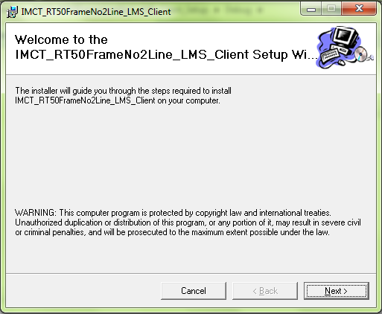
Figure 3-4 first screen of application setup
Click the Next button program will shown as the Figure 5 for select the installed folder (the default is “C:\Program Files\Omron Electronics\ IMCT_RT50FrameNo2Line_LMS_Client”)

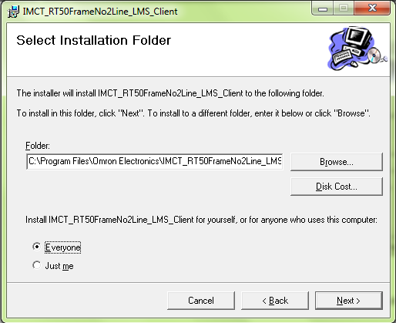
Figure 3-5 Dialog for ask the installed folder
After define the installed folder click the Next button, program will show the dialog as Figure 3-6
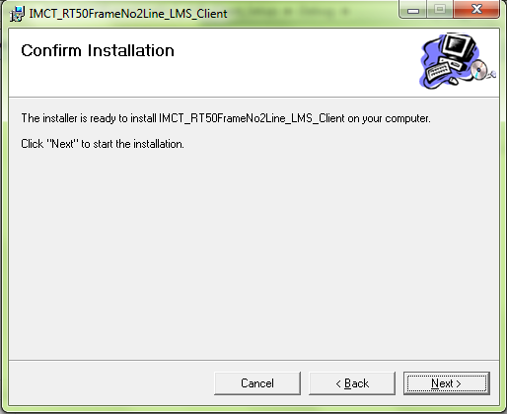
Figure 3-6 Confirm Installation dialog
Click the Next button the progress bar of installation will be shown as Figure 3-7
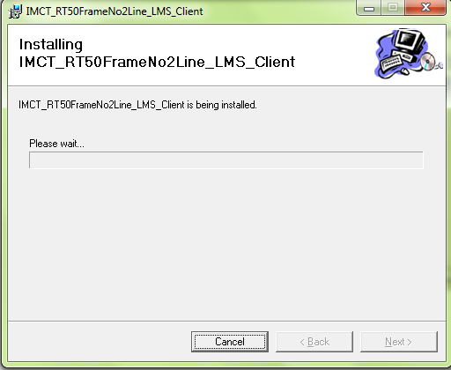
Figure 3-7 the progress bar of installation

After the installation is completely installed the Installation Complete dialog will be shown as Figure 3-8
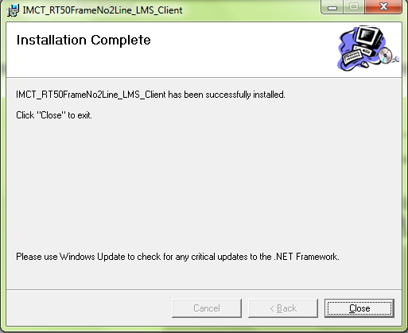
Figure 3-8 Installation complete dialog
Click the Close button for finish install.
After completed installation of the IMCT_RT50FrameNo2Line_LMS_Client, user can Start up the application by click the Start→Program → IMCT_RT50FrameNo2Line_LMS_Client→ IMCT_RT50FrameNo2Line_LMS_Client, as Figure 3-9, or click the IMCT_RT50FrameNo2Line_LMS_Client button in the desktop, as Figure 3-10

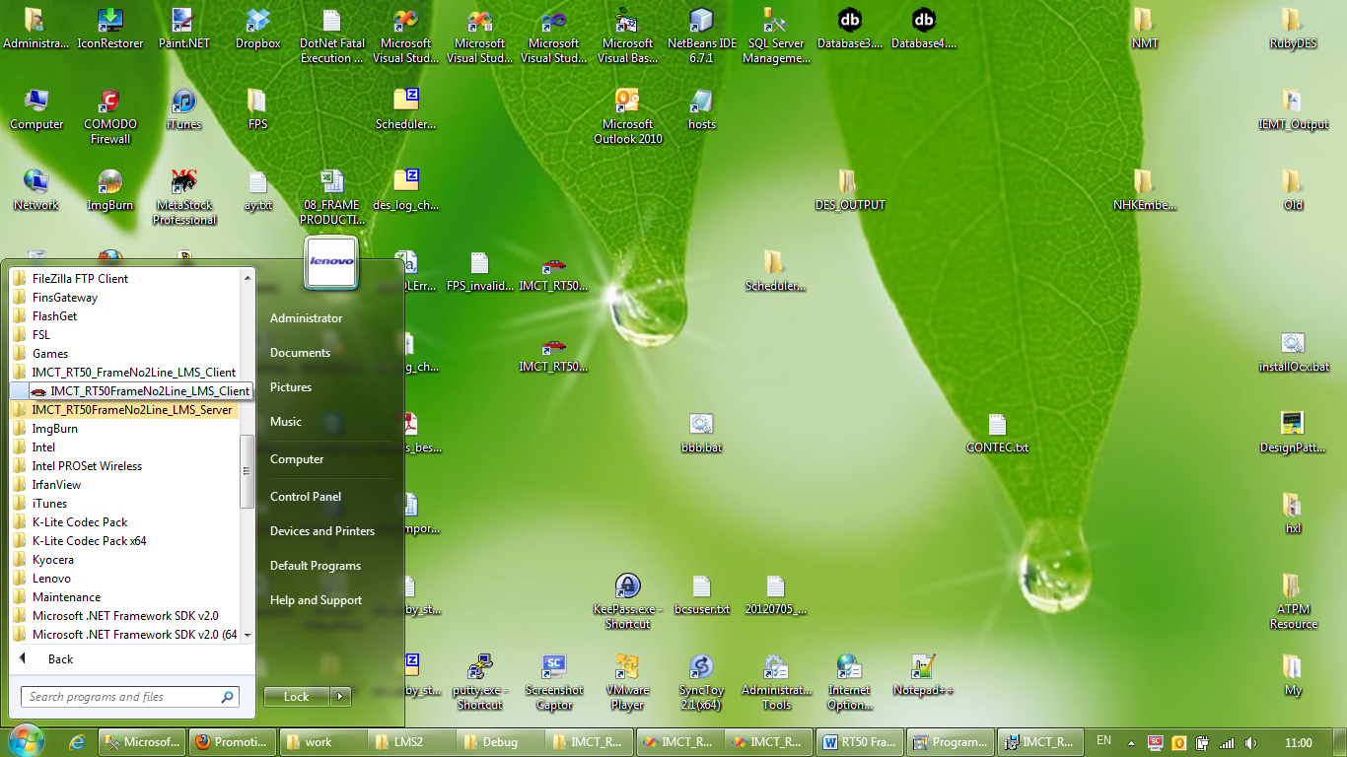
Figure 3-9 Menu in MS-Windows
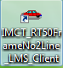
Figure 3-10 the short cut icon in MS-Windows desktop

Changing the configuration
For the first time, after installation completed but before start the application. User must change some setting configuration, for example the Client name (or IP address) , Database instance name, default connection user and password.
Open the application folder (default is “C:\Program Files\Omron Electronics\IMCT_RT50FrameNo2Line_LMS_Client”) as Figure 3-11

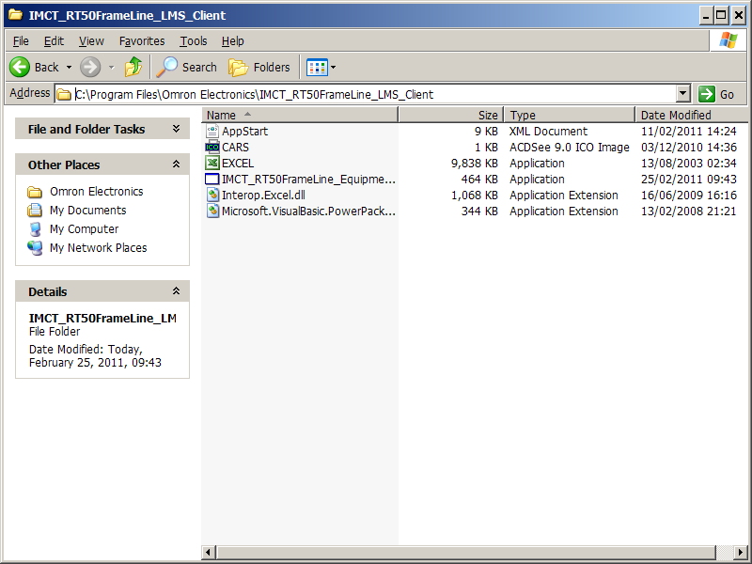
Figure 3-11 Application Folder
Open the file APPSTART.XML and change database connection setting
<AppStart_Config>  <CFG_Name>DB_INITIAL_CATALOG</CFG_Name>  <CFG_Value> IMCT_FrameLineNo2_EMS_DB </CFG_Value>  </AppStart_Config> | Database Name must be “IMCT_FrameLine_EMS_DB”
<AppStart_Config>  <CFG_Name>DB_DATA_SOURCE</CFG_Name>  <CFG_Value>localhost</CFG_Value>  </AppStart_Config> | Client name and database instance (default is localhost). For example if the Clientname is “PISServer” and Database name is “SQL2008”, change the localhost to be PISSERVER\SQL2008 or IP Address for example 192.148.1.150\SQL2008
<AppStart_Config>  <CFG_Name>DB_CONNECT_USERNAME</CFG_Name>  <CFG_Value>sa</CFG_Value>  </AppStart_Config> | Change to be the actual connection user name
<AppStart_Config>  <CFG_Name>DB_CONNECT_PASSWORD</CFG_Name>  <CFG_Value>omron</CFG_Value>  </AppStart_Config> | Change to be the actual connection password
<AppStart_Config>  <CFG_Name>DB_CONNECT_DEFAULTUSER</CFG_Name>  <CFG_Value>1</CFG_Value>  </AppStart_Config> | Change to be “0”

IP Address Setting
Setting of the IP address
No. | Name | IP Address | Notes
1 | Server | 192.168.50.52 | To AS/400
2 | Server | 192.148.1.150 | To Production Control System
3 | AS400 | 192.168.1.41
3 | PIS PC | 192.148.1.153
4 | LMS PC | 192.148.1.154
5 | No.1 G/W PLC | 192.148.1.151
6 | No.2 G/W PLC | 192.148.1.155
7 | No.1 PPB | 192.148.1.152
8 | No.2 PPB | 192.148.1.156

